Contact: Stephanie Sun, Marketing Manager
ssun@contemporarycraft.org
412.261.7003 x29
www.contemporarycraft.org

FOR IMMEDIATE RELEASE
Elizabeth R. Raphael Founder’s Prize Winner Announced at Transformation 10 Exhibition Opening
Transformation 10 Exhibition Highlights Cutting Edge Artworks in Found Materials

PITTSBURGH, PA – August 29, 2018 – Melissa Cameron of Seattle, WA has been selected as the winner of Contemporary Craft’s (CC) 2017 Elizabeth R. Raphael Founder’s Prize. Cameron will be present at the Transformation 10: Contemporary Works in Found Materials, The Elizabeth R. Raphael Founder’s Prize Exhibition opening reception to receive a $5,000 cash prize. Merit Award honoree, James Arendt of Conway, SC and Honorable Mention honoree, Fumi Amano of Seattle, WA, will also be announced at the exhibition opening on September 14, 2018 from 5:30 – 8 PM at CC.

The jury for the 2018 Raphael Founder’s Prize was composed of Fabio Fernández, former Executive Director of Society of Arts and Crafts, Boston, MA; Susie Ganch, Associate Professor and Interim Chair of the Metal Program for the Department of Craft and Material Studies at Virginia Commonwealth University, Richmond, VA; Catherine Raphael, metalsmith and storyteller, Pittsburgh, PA; Kate Lydon, Director of Exhibitions at CC; and Janet McCall, Executive Director at CC. “This prize honors and supports artists who are redefining the boundaries of their media to create innovative work that is challenging, engaging, and thought-provoking. The strength and recognition of this award has grown over the past 18 years and continues to challenge our viewers understanding of craft today,” said McCall.

Transformation 10, an exhibition complementary to the Raphael Founder’s Prize, will feature the work of all 26 of the Raphael Prize finalists from the U.S and abroad, including the winner and honorable mention honorees. The exhibition will highlight innovative examples of newly created contemporary works that incorporated found materials in unexpected ways for personal and global narratives, expressions, and aesthetics. Transformation 10 will be on view from September 14, 2018 to March 9, 2019 in the CC’s main galleries in the Strip District. A “Dialogue with the Artists” will be held on Saturday, September 15 from 12 – 2 PM, which visitors can talk informally with the exhibiting artists about their work and creative process. Following the “Dialogue with the Artists,” Cameron, the winner of Raphael Founder’s Prize, will lead an artist talk to share her creative process and artistic career.

During the run of the exhibition, a free hands-on art activity designed by one of the exhibiting artists, Michelle Stitzlein, will be available in the Drop-In Studio during public hours. It offers the perfect contemplating moment and space for the visitors to talk about the exhibition. A fully illustrated catalogue of the exhibition featuring all exhibiting finalists will be available at CC for $18.

MELISSA CAMERON – 2017 RAPHAEL PRIZE WINNER
Cameron’s winning entry - 1.1.2017 - catalogues one day of gun violence in the USA. Began with her blog post series, “Monday – Gun Day” in 2013, Cameron has made series of artworks that used the imagery and silhouettes of weaponry to make a statement about humanity’s continuing poor relationship with itself. After hearing the news about the October 1, 2017 mass shooting in Las Vegas,

- more -

Cameron was not only horrified by the 59 deaths by one person in a day, but also thought about the other gun deaths that happen daily in this country that people know so little about. People have become inured by the frequency of everyday gun violence that they don’t make it to the national news and this is an issue Cameron wants to address.

Through Gun Violence Archive, an online-based, independent data collection and research group, Cameron researched all the incidents that happened on a specific date, January 1, 2017. A total of 62 fatal gun incidents happened in 55 places throughout the U.S on that one day with 66 guns involved and 73 people affected. After finding out the weapons that were used in the incidents, Cameron then collected metal, plastic, fabric, or paper containers from those 55 places where the acts of gun violence occurred. Matching the containers with the corresponding weapon, she made a portrait of each of the 66 guns used from the container’s body, rendering the containers useless for their former purpose. As the 2017 Raphael Prize winner, Cameron will show several other works in Transformation 10.

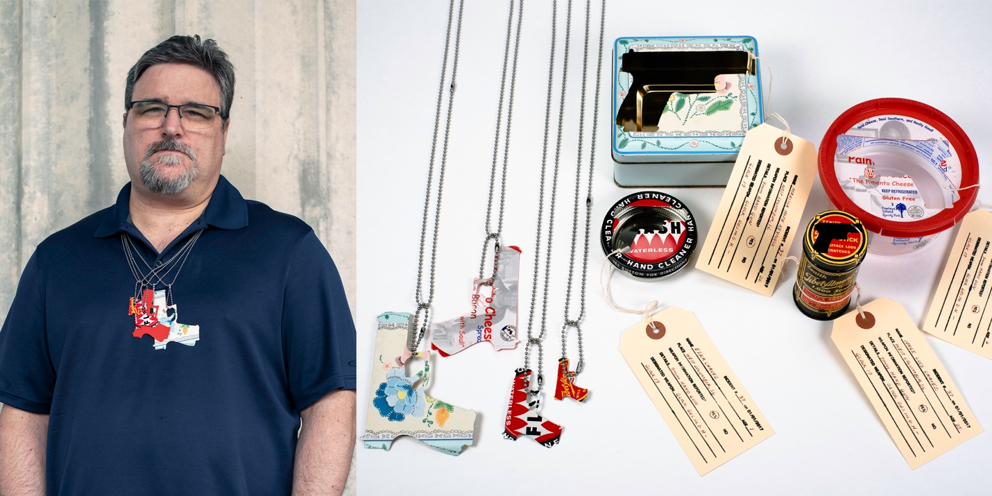
Melissa Cameron. 1.1.2017 (Detail), 2018. Sourced/found objects, stainless steel, card, string. 72” x 24” x 12”. Photo: Melissa Cameron.
Cameron is an Australian-born artist jeweler who lives and works in Seattle, WA. She is a research jeweler; the jewelry she produced speaks to her interest in architecture, social justice, and the human body. Through her work, she manifests her belief in the interdependence of all matter and the sacredness of human life. Cameron exhibits worldwide. Her works are in the collections of the National Gallery of Australia, (Canberra), the Arts Centre Melbourne (Australia), The Powerhouse Museum, (Sydney, Australia) and the Cheongju City Collection, and her pieces have featured in the publications Jewel Book, Art Jewellery Today 3 and Lark Books’ 500 Silver Jewelry Designs. She is the recipient of multiple grants from the Australia Council for the Arts and a Fellowship grant from Artist Trust in Seattle. Her writing appears on Art Jewelry Forum, and she serves on the Metalsmith Magazine Editorial Advisory Committee.

JAMES ARENDT – 2017 RAPHAEL FOUNDER’S PRIZE MERIT AWARD HONOREE
A Merit Award will be presented to James Arendt of Conway, SC. James’ work explores the shifting paradigms of place and labor through found materials that resonate with the work and the people engaged in it. Making do, a concept of thrift and pragmatism that dictates the work with the materials at and, is a craft James learned from the people he grew up with near Flint, MI. Influenced by the radical

- more -

reshaping of the rural and industrial landscapes in which he was raised, he investigates how individual lives are affected by transitions in economic structures. Denim seems created to be abused, worn out, patched, stained, and burnt through, which are characteristics that mirrored in the people he chooses to represent.

FUMI AMANO – 2017 RAPHAEL FOUNDER’S PRIZE HONORABLE MENTION HONOREE
An Honorable Mention Award will be given to Fumi Amano of Seattle, WA. As a Japanese woman living in the United States, she often struggles with her attempts at communication. The frustration from miscommunication and prejudice to Asian women inspired her to make sculptures and performance art pieces that express the feeling she cannot explain in words. To Fumi, glass is a material she chose specifically because it connects people as well as acting as an invisible filter between people. Her work expresses the intense support of being loved, but also the unsuccessful attempts people make at developing true bonds.

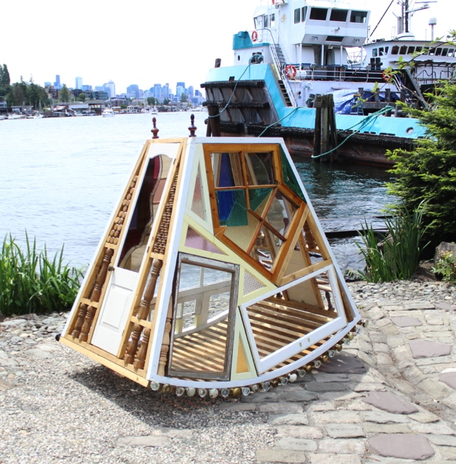 | 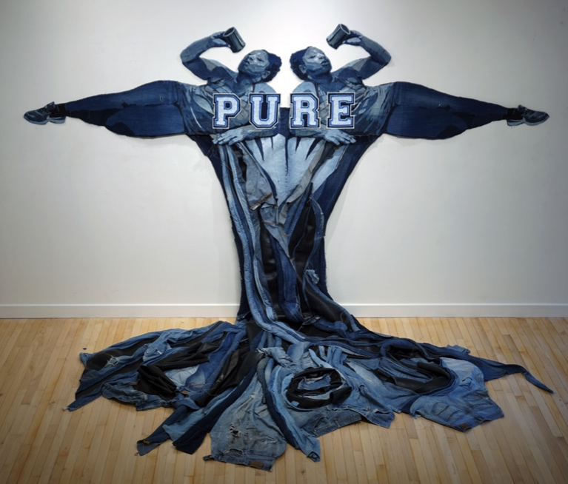
Fumi Amano. Bassinet, 2018. Old window frames, old furnitures. 72” x 72” x 36”. Photo courtesy of Fumi Amano. | James Arendt. Adrian: Lies, 2018. Reclaimed denim, discard inner tubes. 84” x 84” x 48”. Photo courtesy of James Arendt.
Please contact Stephanie Sun at ssun@contemporarycraft.org for more information about the Raphael Founder’s Prize and Transformation 10, and request for high-res images for Transformation 10.

EXHIBITION FUNDERS
Transformation 10: Contemporary Works in Found Materials is made possible by Alexandra and Catherine Raphael, The Fine Foundation, the Allegheny Regional Asset District, the Pennsylvania Council on the Arts, the Elizabeth R. Raphael Fund of The Pittsburgh Foundation, and Cohen & Grigsby. Media sponsored by NEXTpittsburgh.

ABOUT TRANSFORMATION EXHIBITION SERIES
The Transformation series, one of the CC’s signature programs, was established in 1997 as a biennial juried exhibition focusing on traditional craft media – glass, wood, metal, clay, and found materials – in rotation. The exhibition seeks out an international selection of artists redefining their medium to create work that is challenging and thought provoking; inviting us all to reconsider our notion of “craft.” Presenting contemporary art in craft materials by regional, national, and international artists since

- more -

ABOUT CONTEMPORARY CRAFT
1971, CC offers cutting edge exhibitions focusing on multicultural diversity and perspectives, as well as a range of studio workshops, community outreach programs, and a store specialized in contemporary craft. Through its mission of engaging the public in creative experiences through contemporary craft, CC offers meaningful art opportunities for 135,000 people a year through four core values: providing vital support for artists, filling critical gaps in public education; sharing cross cultural perspectives; and using art to build community.

CC is located at 2100 Smallman Street in the Strip District of Pittsburgh, PA. Hours are Monday through Saturday, 10 AM to 5 PM. Exhibition and informal, hands-on art activities in the Drop-In Studio are always free to the public. Contemporary Craft is committed to making its exhibitions, programs, and services accessible to the public. For questions related to accessible accommodations, please contact us. For more information, visit http://www.contemporarycraft.org or call 412.261.7003.

# # #

