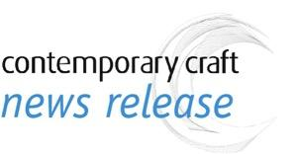 | Contact: Stephanie Sun, Marketing Manager  ssun@contemporarycraft.org  412.261.7003 x29  www.contemporarycraft.org

FOR IMMEDIATE RELEASE
Contemporary Craft showcases new work by Pittsburgh Artist Kim Fox
Non-traditional tin quilts that focus on the notion of home within the Pennsylvania landscape

PITTSBURGH, PA – July 25, 2018 – Featuring a selection of vibrant new works by Pittsburgh artist Kim Fox, Handwork recognizes the influence, patterns, and landscapes of Pennsylvania. On view from September 14, 2018 to January 5, 2019 at Contemporary Craft’s (CC) BNY Mellon Satellite Gallery, Handwork showcase Fox’s untraditional “quilts” created with vintage tin and salvaged wood that combine images reminiscent of traditional quilt patterns and the ideals they represent, as well as a focus on organic themes of birds, bees, and the idea of home and place.

Inspired by her urban surroundings and the natural Pennsylvania landscape, Fox creates contemporary quilts in non-traditional materials; her process of cutting apart tins and sourcing wood is as much a part of the art as the assemblage of the pieces. Fox’s childhood of growing up in rural Western Pennsylvania informed her aesthetic, subject matter, and choice of materials. She recognizes the history that comes with salvaging and reclaiming materials and prefers to work with found materials rather than mimicking the patina of old. To Fox, the circle of decay and rebirth of reclaimed materials is a similar narrative to that of Pittsburgh, a city of dramatic beauty and constant change.

Fox has been making art and showing her work, which began with more traditional painting and collage when she lived in Florida, for more than 15 years. After moving back to Pennsylvania and reclaiming her roots, she explores regional arts and crafts with a more rural bent. Nine years ago she began working with vintage tins and salvaged wood and patchworking the material in a way that felt like quilting.

Fox has taken part in exhibitions at museums and galleries such as The Andy Warhol Museum, Pittsburgh, PA; the Rhode Island State Council on the Arts Atrium Gallery, Providence, RI; and the A.I.R. Gallery, Brooklyn, NY, among others. In addition to making her art, Fox is an art teacher in regional schools in Western Pennsylvania and also is a designer and illustrator, all of which lend a hand to the intricate designs and techniques found in her quilts.

Located in the Lobby of the Steel Plaza T-Station in downtown Pittsburgh, Handwork is free to the public and opens daily through midnight. Handwork is presented in conjunction with CC’s biennial show, Transformation 10: Contemporary Works in Found Materials, The Elizabeth R. Raphael Founders Prize Exhibition, which will be on view in the main galleries in The Strip from September 14, 2018 to March 23, 2019. For more information and high-res photos of Handwork, please contact Stephanie Sun at ssun@contemporarycraft.org or at 412.261.7003.

- more -

FEATURED EXHIBITING ARTWORK FROM HANDWORK

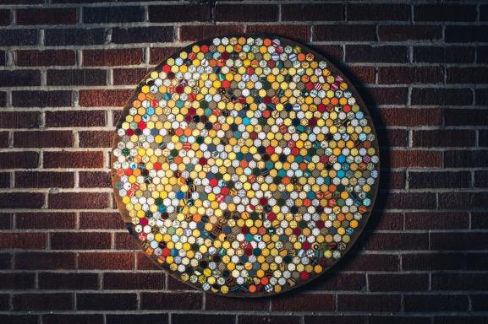
Kim Fox. Honeycomb, 2018. Vintage tin, salvaged wood. 34" in diameter. Photo: Matt Dayak.

Exhibiting artist Kim Fox is “passionate about pattern, repetition, color, and reuse” as can be seen in her feature exhibiting artwork, Honeycomb (shown above). Honeycomb is a 34” circular tin quilt comprised of hundreds of individual hexagons of varied colors. The hexagon, a repeating theme in Fox’s work, connects her art with her past as a beekeeper. Amazed and inspired by a bee’s intuition for the exact mathematical calculations and their ability to create thousands of perfect hexagons, Fox uses the shape in her art as a way of building connections between her art, the bees, traditional quilting patterns, and the sense of community.

ABOUT CONTEMPORARY CRAFT
Presenting contemporary art in craft materials by regional, national, and international artists since 1971, CC offers cutting edge exhibitions focusing on multicultural diversity and art, as well as a range of studio workshops, community outreach programs, and a retail store. Through its mission of engaging the public in creative experiences through contemporary craft, CC offers meaningful art opportunities for 135,000 people a year through four core values: providing vital support for artists, filling critical gaps in public education; sharing cross cultural perspectives; and using art to build community.

CC is located at 2100 Smallman Street in the Strip District of Pittsburgh, PA. Hours are Monday through Saturday, 10 AM to 5 PM. Exhibition and informal, hands-on art activities in the Drop-In Studio are always free to the public. Contemporary Craft is committed to making its exhibitions, programs, and services accessible to the public. For questions related to accessible accommodations, please contact us. For more information, visit http://www.contemporarycraft.org or call 412.261.7003.

# # #

